Project Title

Project Subtitle – Short Description here

# The team

Tell us the story about your team. Were you at a hackathon together, or partnered on a class project? How did you decide to work together to submit to Imagine Cup?

Coming from an engineering background,

**Carlos Henrique Tarjano Santos,** Universidade Federal Fluminense, MSc, 2018 - Short biography

**Mentors:**

* List mentors here
* And how they helped

# The Concept

Many people play guitar, be it acoustic or electric. While some of them go on to transform the hobby into something more, even professionalizing eventually, the majority are hobbyists, that play to relieve some stress, entertain friends, or even to make their brain sharper. For this last group, it is not uncommon to forget some of the songs you learned along the way. Maybe you can even pull of the chorus, but struggle to remember how the song begins, or the chords that make that exoteric bridge.

Mark Book provides the amateur guitarist the ability to carry his songbook with him all the time, be it on the cellphone, desktop or web. Those a little older probably had contact with magazines full of chords and lyrics. Nowadays websites filled that niche, and you can refresh your memory searching for a tab.

But more often that not, the tabs in those places are a little of, and the presentation is not as compact as it could be. Mark Book is an app that provides you a simple and efficient way to carry your songbooks with you all the time. It uses a very simple markup language, inspired by markdown, to encode your songs in an human readable, open format, and renders this source file beautifully and compactly, with chord diagrams above the chords and other conveniences.

## Target Audience or Market:

We designed and built Mark Book with the amateur guitarist in mind, but it certainly can be used by professional artists, perhaps when doing a voice and guitar presentation. We kept the user interface and the options minimal, to make usage simple and intuitive. Although at the moment the command descriptions are in English, the interface is mostly visual, to be accessible to people with little familiarity to the language.

### Personas

One archetypal user would be the heart of the party type of guy, that loves to carry his acoustic guitar when gathering with his friends. There are some of those who still carry an old school songbook in the pocket of his acoustic guitar case, but not our guy. This Mark Booker just fires his cellphone and is ready to play even the songs he doesn’t have played in years. He can even share his songbook with his friends – even if they don’t use Mark book, they can still read and understand the format in virtually any device that is able to read a .txt file.

## Feedback

Pitch your core concept to a few people who would be in your audience or who have expertise in the kind of project you are making. Note here what you learned from them. The more sources of early feedback you include, the better.

# How it works:

Use this section to talk about how you built your product, how have Microsoft technologies made it feasible?

Include an architecture diagram in this section (example given below). If you need Microsoft-icons, you can [download them here](https://docs.microsoft.com/en-us/azure/architecture/resources/diagrams).

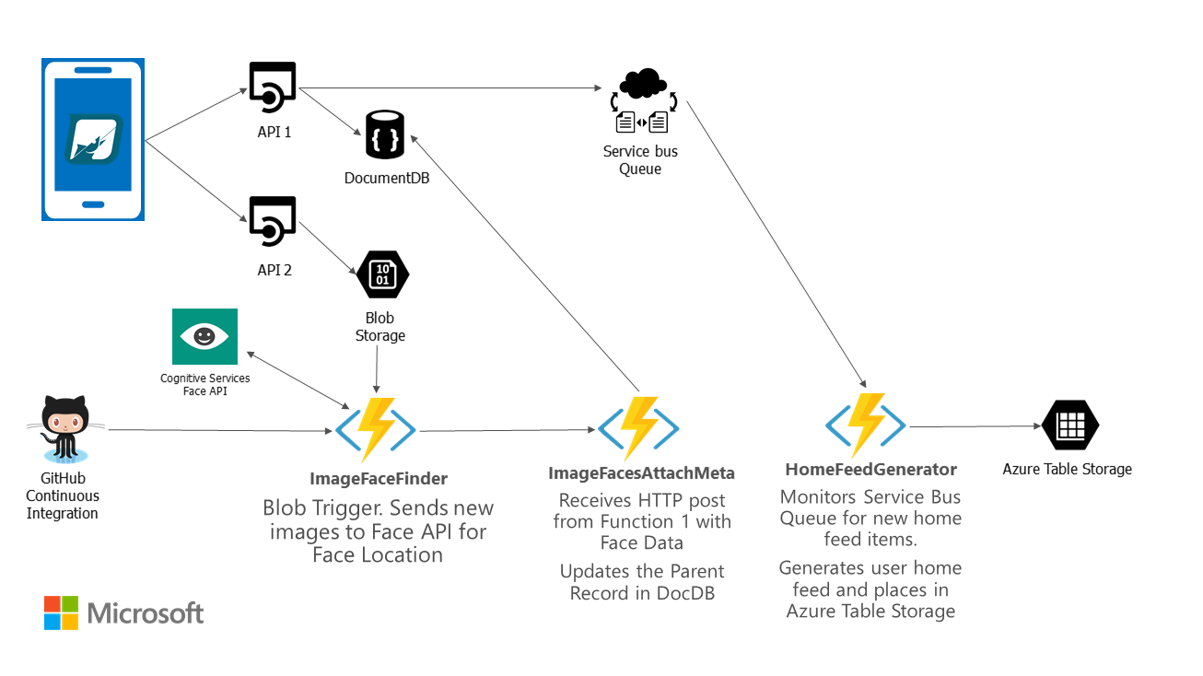

Think about the following questions, when writing this section:

* Does the project make effective and appropriate use of the major features of its chosen platform(s)?
* Were there significant platform features or even platforms the project could have benefitted from but failed to utilize?
* Does the project include innovations in technical design and/or implementation?
* Does the project include innovations in user experience?
* Does the project have a professional degree of production in terms of performance, user interface, visuals, and audio?

## Core Technologies

This includes your key platform(s) as well as specific technologies such as the Kinect SDK, the Unity game engine, or other elements that you believe will be critical to your project’s success.

# The Business Plan:

You don’t need to have a fully fleshed out business plan, we just want to know that you’ve put time into thinking about it.

## Competition:

What products, companies, or services will you directly compete with for your audience? How do you expect to differentiate your project from your competitors?

Think about the following questions in this section:

* Does the project create a new category of product or service?
* Does the project clearly and meaningfully innovate beyond existing products or services?

## Business Model

How will your project make money? If it provides an ongoing service, how will that service be sustainable? If there are critical partnerships you must make for your business model to work, describe those here as well.

Think about the following questions in this section:

* Does the team have a credible plan for getting their project to market in terms of business model, any required partnerships, or other factors?
* Does the project have a reasonable chance of success in its appropriate market given the team’s existing plan?

# Additional Information:

Add any links or information here. Any information you want to share is welcomed!